Planning Matters
SUMMARY OF PRIORITIES
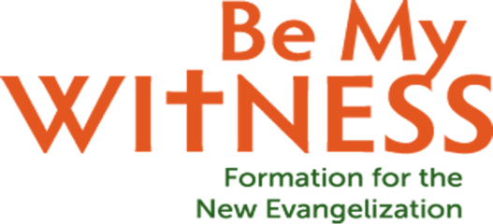
- Sunday, Sacraments and Worship Matter
Encourage full participation in the Mass
Upgrade audio system which was poor (completed)
Purchase hymn board
Adjust volumes
Announce pages so people can follow along
- Welcome, Belonging and Community Matter
Welcome everyone
Recruit additional greeters; esp. 4pm Mass
Encourage people to say hello and introduce themselves
Get to know new people
Make it easy for new people to join
Develop Welcome Brochure
Identify host families
Once people join encourage them to get involved
Build strong presence of the Youth
Participation in Youth Convention
Create sense of community
Personally invite people to join, not just bulletin announcements
Hold a parish ministry day
Support one another, pray for one another; form men and women’s prayer groups
Hold events like Easter Egg Hunt
Improve communication
Website
Facebook or social media
Visible publicity like posters
- Witness and Faith Formation For Everyone Matter
Encourage people to talk about their faith
Put faith stories in bulletins, website and social media
Move forward with BMW Phase 2 small faith sharing groups
Help people to grow in their faith
Send packet home to families (RCIA?)
Hold Vacation Bible School
Encourage interfaith activities
Invite youth to bring friends
- Mission, Service and Charity Matter
Deepen understanding of Catholic Social Teaching
Augment online information
Continue Fr. Matt’s emails
Support Pro-life; Life chain; Unbound; Outreach International
Twin with an inner city parish; second collection
- Leadership Formation Matters
Help form leaders and ministers
Use BMW videos to continue to discuss themes
Provide training for ushers and greeters, showing them Welcome Matters video

